- Write a program that prints out a list of the integers from 1 to20 and their squares.
- Write a program that uses a for loop to print the numbers 8, 11, 14, 17, 20, ..., 83, 86, 89.
- Write a program that uses a for loop to print the numbers 100, 98, 96, ..., 4, 2.
- Use a for loop to print an upside-down triangle like the one below. Allow the user to specify how high the triangle should be.
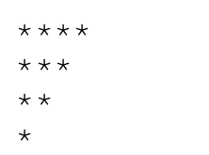
- Use for loops to print a diamond like the one below. Allow the user to specify how high the diamond should be.
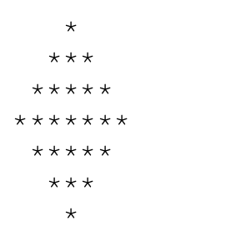
- Write a Python program that takes a user input (positive integer). The program should then iterate through numbers from 1 to that number (both inclusive) and print "tik" if the current number is divisible by 3; otherwise, it should print "tok".

